A student is writing a report about the branches of the United States government. Read both the text source and the visual source and the directions that follow.
The United States federal government is designed to separate control of legislative, executive, and judicial powers. Each branch has methods to check the powers of the other two. The legislature can change the laws that the executive and judicial branches must enforce. The executive branch can veto, or reject, legislative decisions. The executive branch can also nominate judges. Finally, the judicial branch can decide if actions taken by the other two branches are legal.

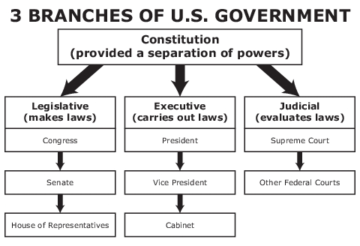
The student took notes about information in the sources. Which note correctly paraphrases, or restates, information from both sources?
 |  | A | The Supreme Court makes decisions that can overturn the decisions of other federal courts.

 |  | B | The Constitution is considered more powerful than any of the three branches of government.

 |  | C | The legislative branch is expected to work together to check the power of the other two branches.

D | The three major types of government power are divided between different branches of government.

