I Declare!
Over the next week, you will be putting yourself into Thomas Jefferson’s shoes and writing a declaration of something. You may choose anything to declare, however it must be school appropriate and you must be able to support your reasons with actual facts. Although what you will be declaring is in modern times, you will be writing as if it was written in the 1700’s. You will use similar language to how Jefferson wrote, most specifically his “beautiful phrasing, the consistently elegant tone, the quiet dignity of the words chosen and the air of philosophical reflection”(Revolutionary Grammar, Michael Clay Thompson).
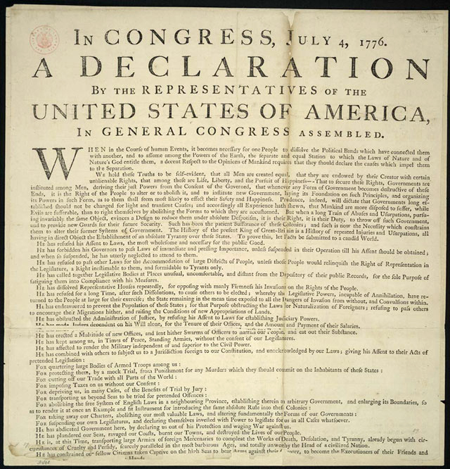
A few examples:
- New school lunch program
- Later starting time for school
- Own bedroom at home
- Later bedtime
- More freedom on the weekends
Requirements:
- Must be something that can be declared!
- 5 supported/ factual reasons for why you are declaring this
- At least a page in length
- Vocabulary words from this week AND last (minimum of 5 total)
- Present your declaration to the class on Wednesday Nov. 19 (next week)
To remember while writing: From “Revolutionary Grammar”
- Gentlemen do not raise their voices
- Jefferson’s words were almost mesmerizing
- Confidence is self-sufficient and seamless in the document, and extends not only through the vocabulary but also to the grammar.
- Writing is NOT elementary, not crude, not choppy
- Writing is refined, elegant and harmonious with the choice of words

